DESIGN:

This code consists of three source files, main.cpp, MapHandler.h, and MapHandler.cpp.

MapHandler is an object that contains a map with a string key (the item’s name), and an integer value (the item’s frequency in the dataset). It also contains a vector storing the names of all the keys, for easier iteration through the map. Its functions add items to the map, display the menu, execute the user menu options, read the input file, and create and populate an output file. This keeps the code in main.cpp relatively short, and the separate functions make the code more readable.

Main.cpp contains a loop that displays the menu, prompts the user for a menu choice, and executes the user’s choice from the menu.

FUNCTIONALITY:

When the user runs the program, they are greeted with this menu:

The instructions are on the menu. The user must type an integer, and then press the enter key.

When the user enters 1, they are prompted to search for an item in the cart. They must type the name of an item (which must be capitalized, given the data provided), and press enter. They are then given the text [Item name]: [Frequency of item in the given data]. If the item is not on the list, “The list does not have [item name].” is output.

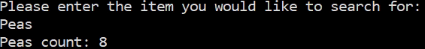

When the user enters 2, they are given a list of every item and its frequency.

(The list continues further than this screenshot.)

When the user enters 3, they are given a histogram of every item and its frequency.

(The histogram continues further than this screenshot.)

When the user enters 4, the program terminates.

After every menu option aside from option 4, the menu displays again.

A data file named “frequency.dat” is created, and it contains the names of items and their frequencies.